Лабораторная работа№ 2

1. Генерируем API openweathermap.org.

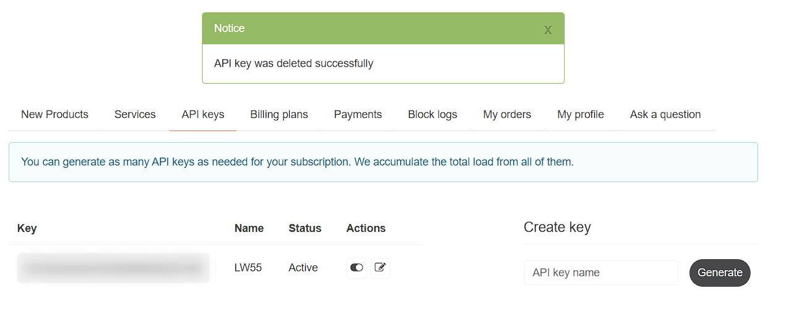
2. Модуль getweatherdata.py с функцией для URL запроса к API openweathermap.org и формирования json ответа.

def get_weather_data(place, api_key=None):
if api_key is None:
raise ValueError("API key is required")

url = f'https://api.openweathermap.org/data/2.5/weather?q={place}&appid={api_key}&units=metric'

response = requests.get(url)

if response.status_code != 200:
response.raise_for_status()

data = response.json()

city_name = data['name']
country_code = data['sys']['country']
lat = data['coord']['lat']
lon = data['coord']['lon']
feels_like = data['main']['feels_like']
timezone = data['timezone']

timezone_hours = timezone // 3600
timezone_str = f"UTC{'+' if timezone_hours >= 0 else '-'}{abs(timezone_hours)}"

result = {
"name": city_name,
"coord": {"lon": lon, "lat": lat},
"country": country_code,
"feels_like": feels_like,
"timezone": timezone_str
}

return json.dumps(result, ensure_ascii=False, indent=4)

3. main.py файл для запуска модуля getweatherdata.py
from owm_key import owm_api_key
from getweatherdata import get_weather_data

def main():
cities = ['Chicago', 'Saint Petersburg', 'Dakka']

for city in cities:
try:
weather_data = get_weather_data(city, api_key=owm_api_key)
print(f"Weather data for {city}: {weather_data}")
except Exception as e:
print(f"Error fetching weather data for {city}: {e}")

if __name__ == '__main__':
main()

4. Ответ на примере Чикаго, Санкт-Петербург, Дакка:
